Computer Language Coding Concepts

Commands in a Diagram
Command are actions that the computer can execute.
A command in a diagram is represented by a square.



See also: Commands

Author & Copyright: Jan-Joost van Zon Date: May 24, 2008 – May 24, 2008 Location: Oosterhout, The Netherlands Status: Finished

Use this

A command symbol also has a system interface.

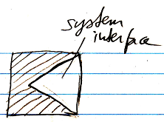

Or with an exaggerated notation:

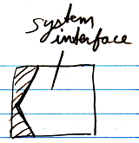

The default members of the system interface of a command symbol are shown belown:

